## horizontal line



Nkozi Tours

Group C

**─**

Members

NDAGIRE CROWIE _ 2025-B201-13111

MUHUMA FREDRICK _2025-B291-13181

MULIRA TENDO MUKISA _ 2025-B291-10549

KISITU VIANNEY _ 2025-B291-13664

ZZIWA VINCENT _ 2025-B201-13832

AGABA KAGUMYA KAKURU _ 2025-B071-13144

# Topic and Purpose

Our topic is Tourism.

Nkozi Tours is a tour planner that enables tourists to book tours to see gorillas in Uganda, beach tours in Kenya and climb Mount Kilimanjaro in Tanzania. Nkozi Tours also provides access to accommodation facilities at partner hotels in East Africa and various means of transportation, boasting a variety of vehicle privileges.

# Description of each page and its functionality

1. Home page

This page provides a quick review of some of the many services provided by Nkozi Tours. It also contains a selection of some of the reviews made by our customers, as well as an FAQ section.

1. About us - Vian

This page basically informs the user what Nkozi Tours is all about, identifies the co-creators and states its mission and why you have to choose us over all the available Tours and travel companies. Once a site user clicks on it from the home page, they are redirected to it for such information.

1. Services - Agaba

This page shows a short description of the services that our tourism board offers, such as the destinations visited, the accommodations available and the transport the customers will use. This page is directly linked to the checkout page, where customers pick their payment package.

1. Signup and login - Crowie

This page is about creating an account on our website, where we have a sign-in page and when you click on create account it takes you to the sign-up page, where a person's details are filled in. This page helps tourists open accounts with our company for easy access to the services provided.

1. Blogs - Fredrick

This page displays the different activities done by the different tourists who have booked and gone on our trips. The page also displays the comments by some of the tourists who visited our destinations.

1. Check Out - Mulira

The checkout page is a section that enables customers to select a service and a payment method before making a payment. It features various payment methods and payment options.

1. Contact and help - Vincent

The page has a contact form that enables users to get in touch with our support Team. It also has an FAQ section for frequently asked questions. Users can enter their email, name and also select the category of the query they ask, before providing details of the query. The FAQ section has some questions and answers that the users can ask about the website.

# Summary of Technologies used

1. HTML

98.5% of our website is made up of basic HTML code.

1. Bootstrap

Almost all elements on the website rely on locally hosted Bootstrap CSS styles, with minor customisations to the default colour themes using a custom Sass file.

1. Vue.js

Our Checkout page uses Vue.js to selectively display content in the checkout and payment sections.

1. Animate On Scroll (AOS)

Our entire website uses the AOS JavaScript library to animate the elements on the screen.

# 

# Screenshots of each page

HOME

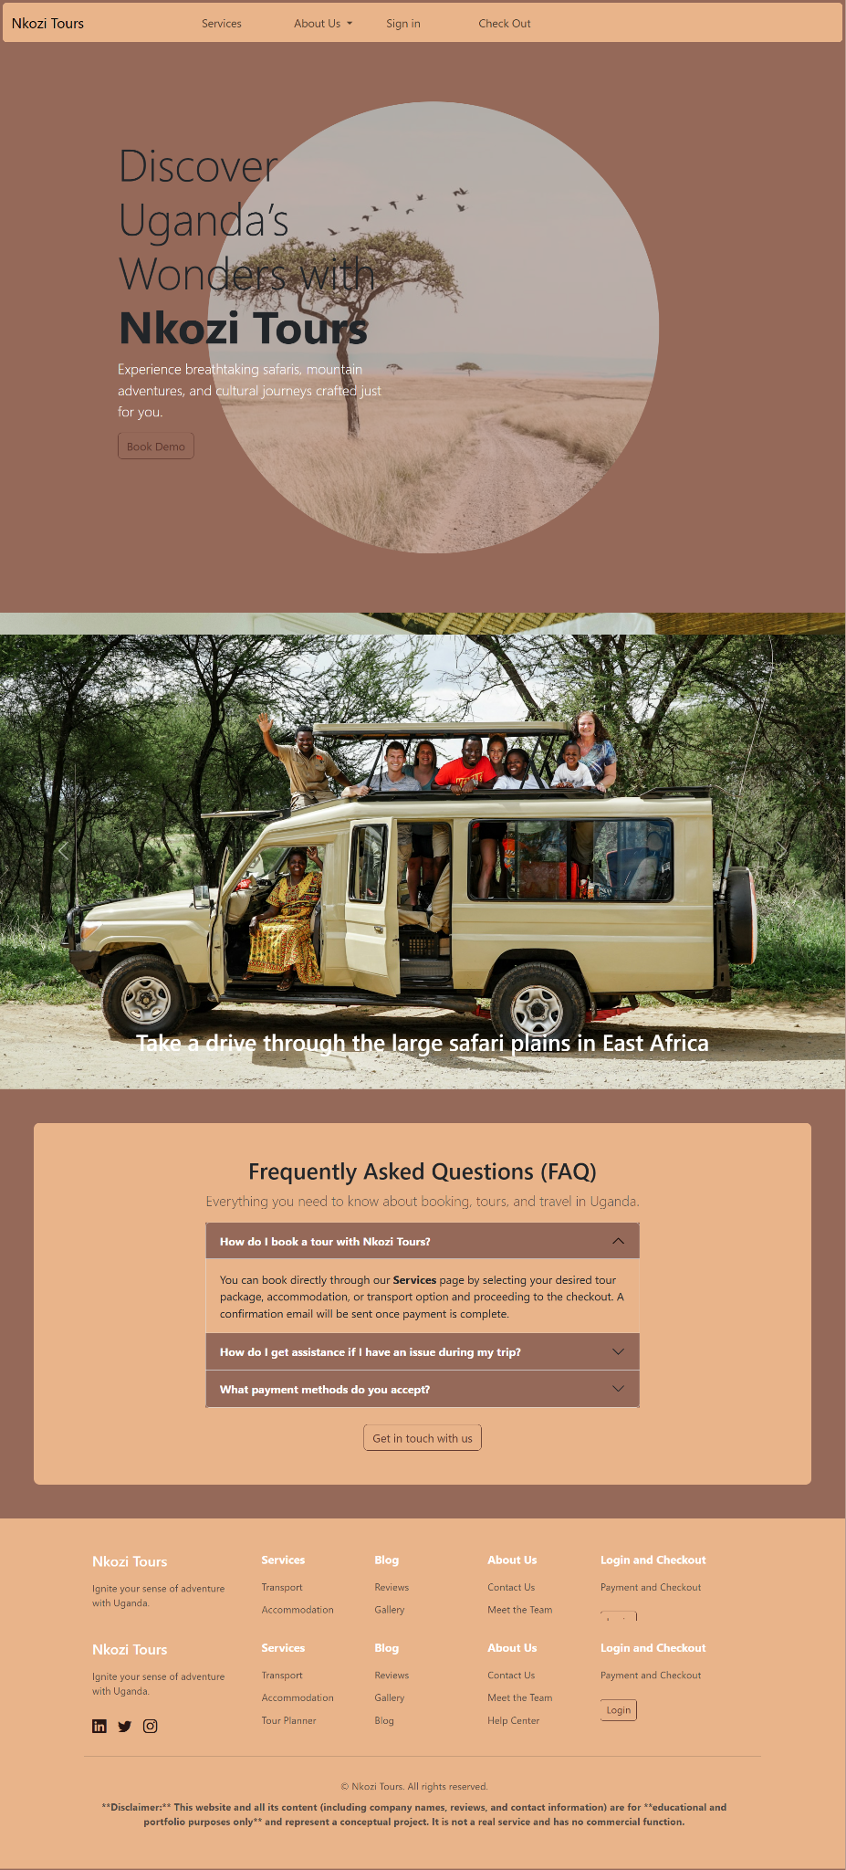

SERVICES

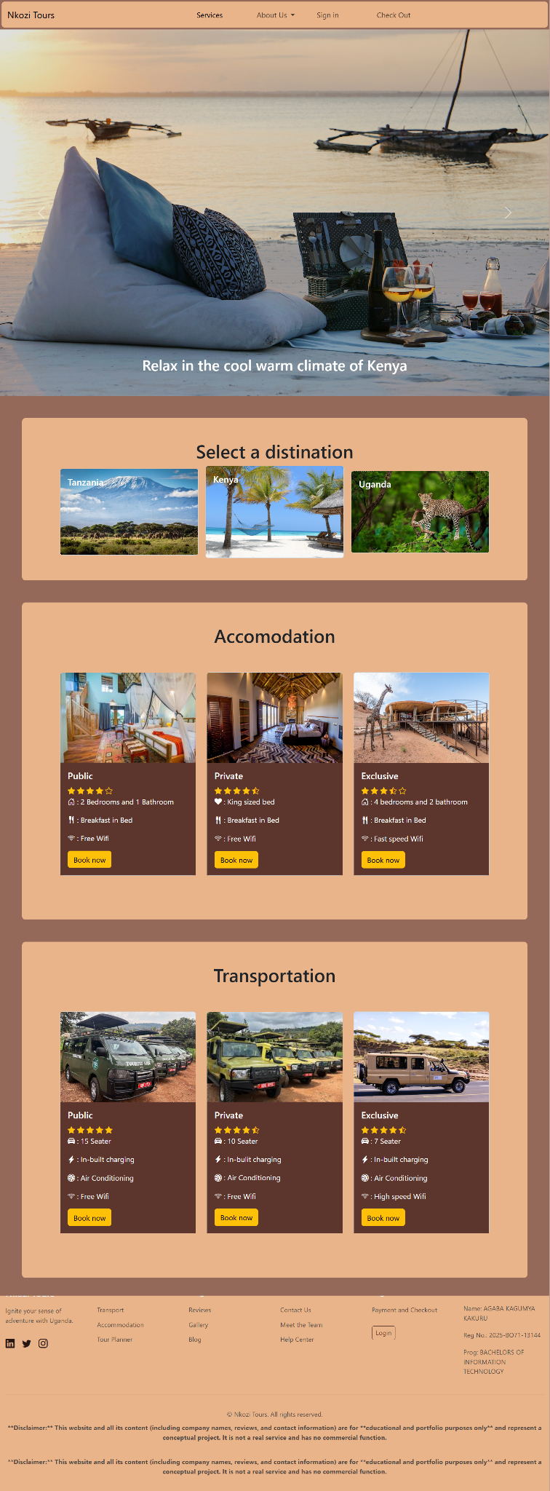

BLOG

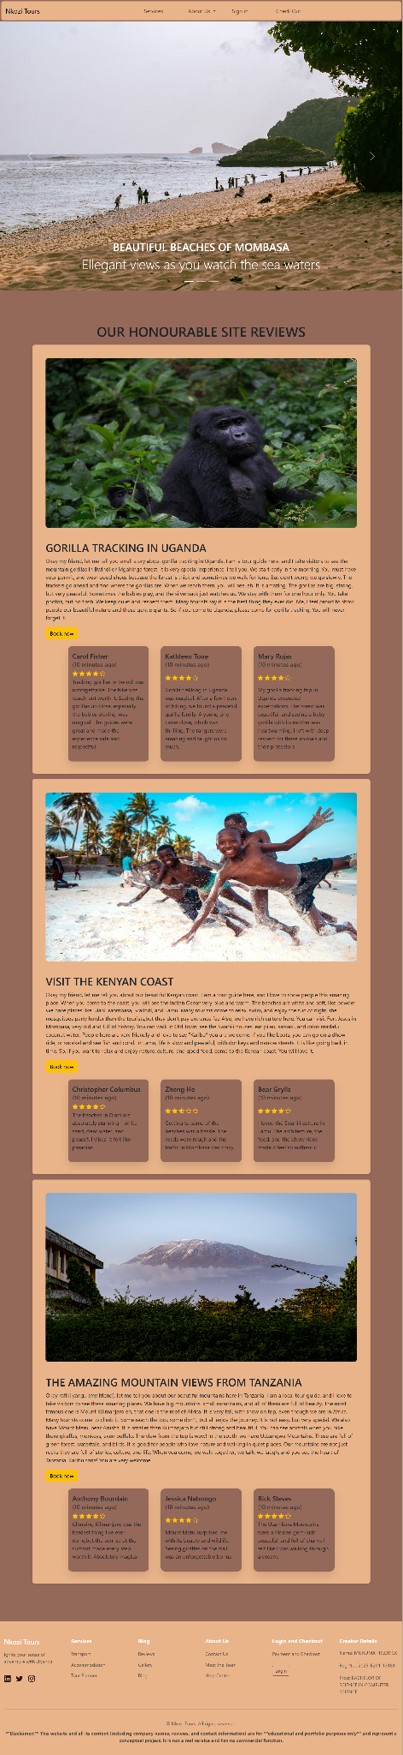

ABOUT US

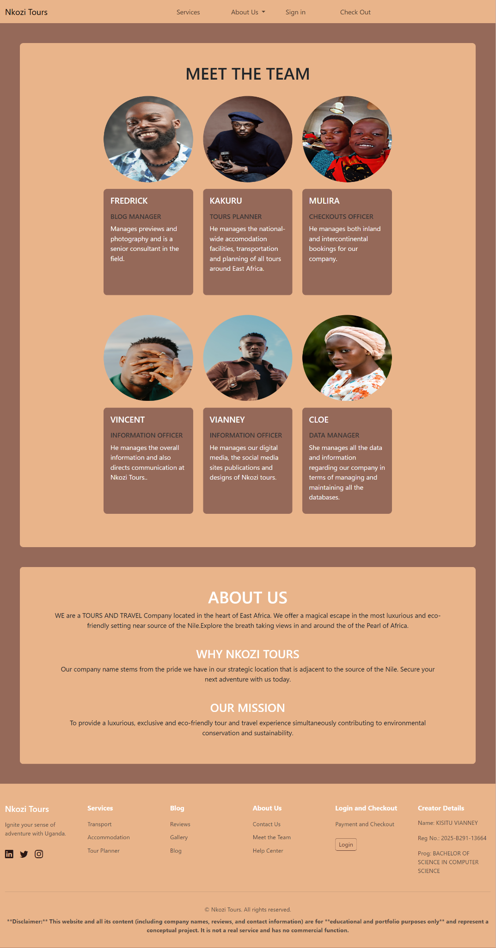

CONTACT AND HELP

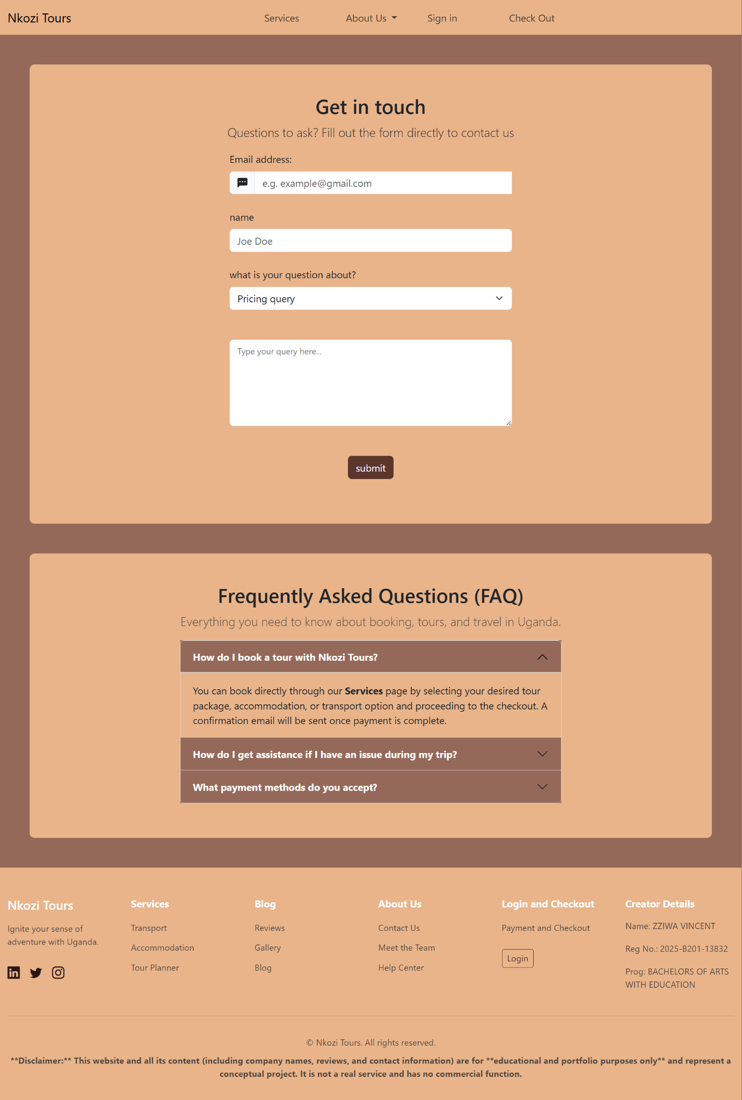

LOGIN

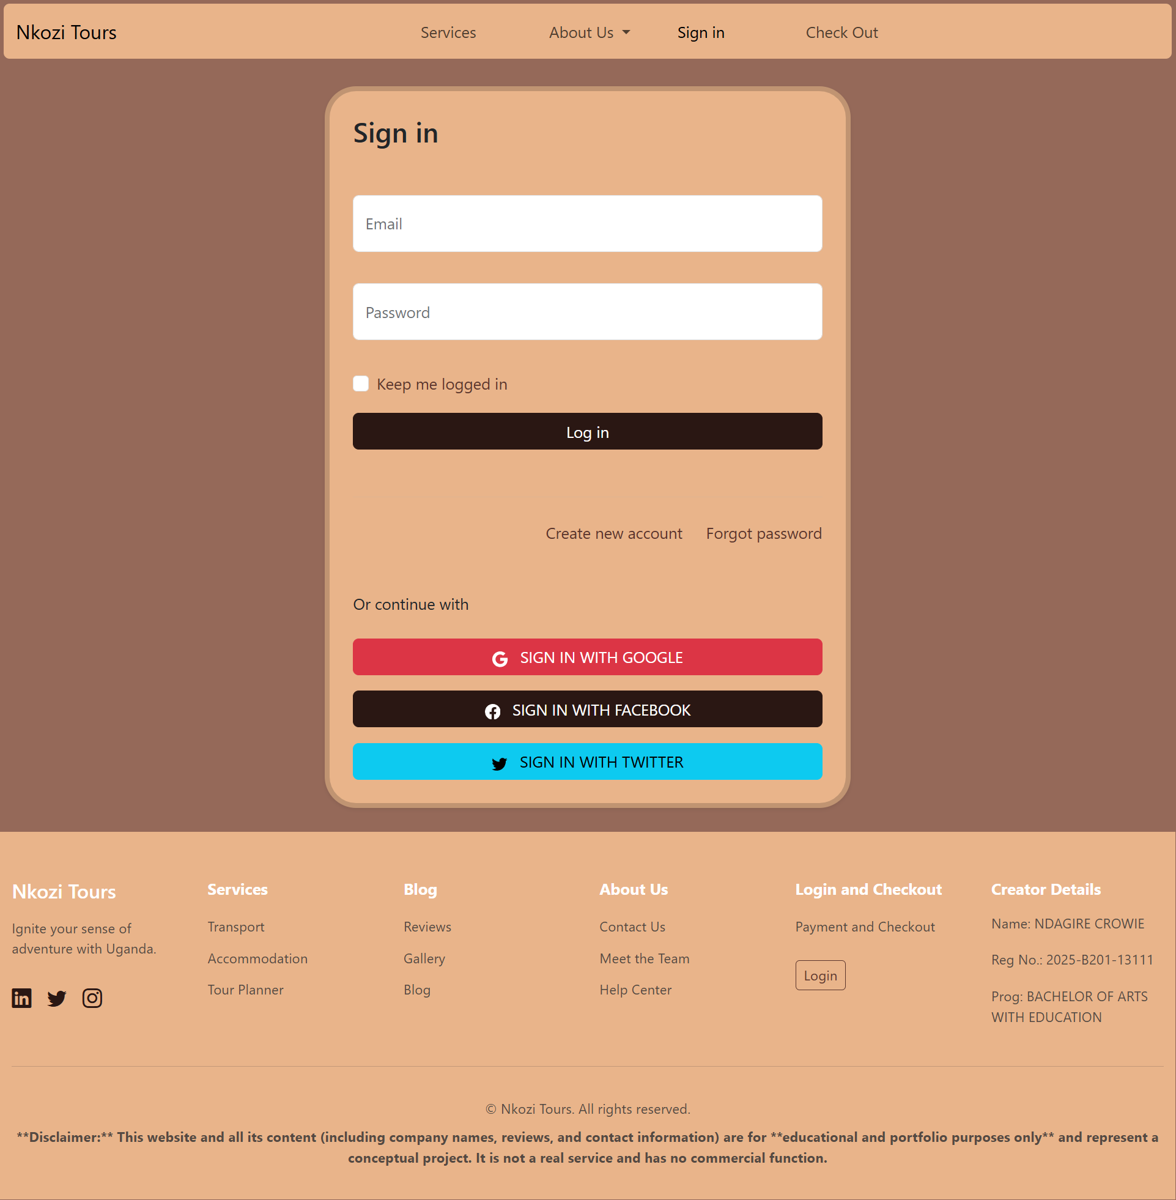

SIGN UP

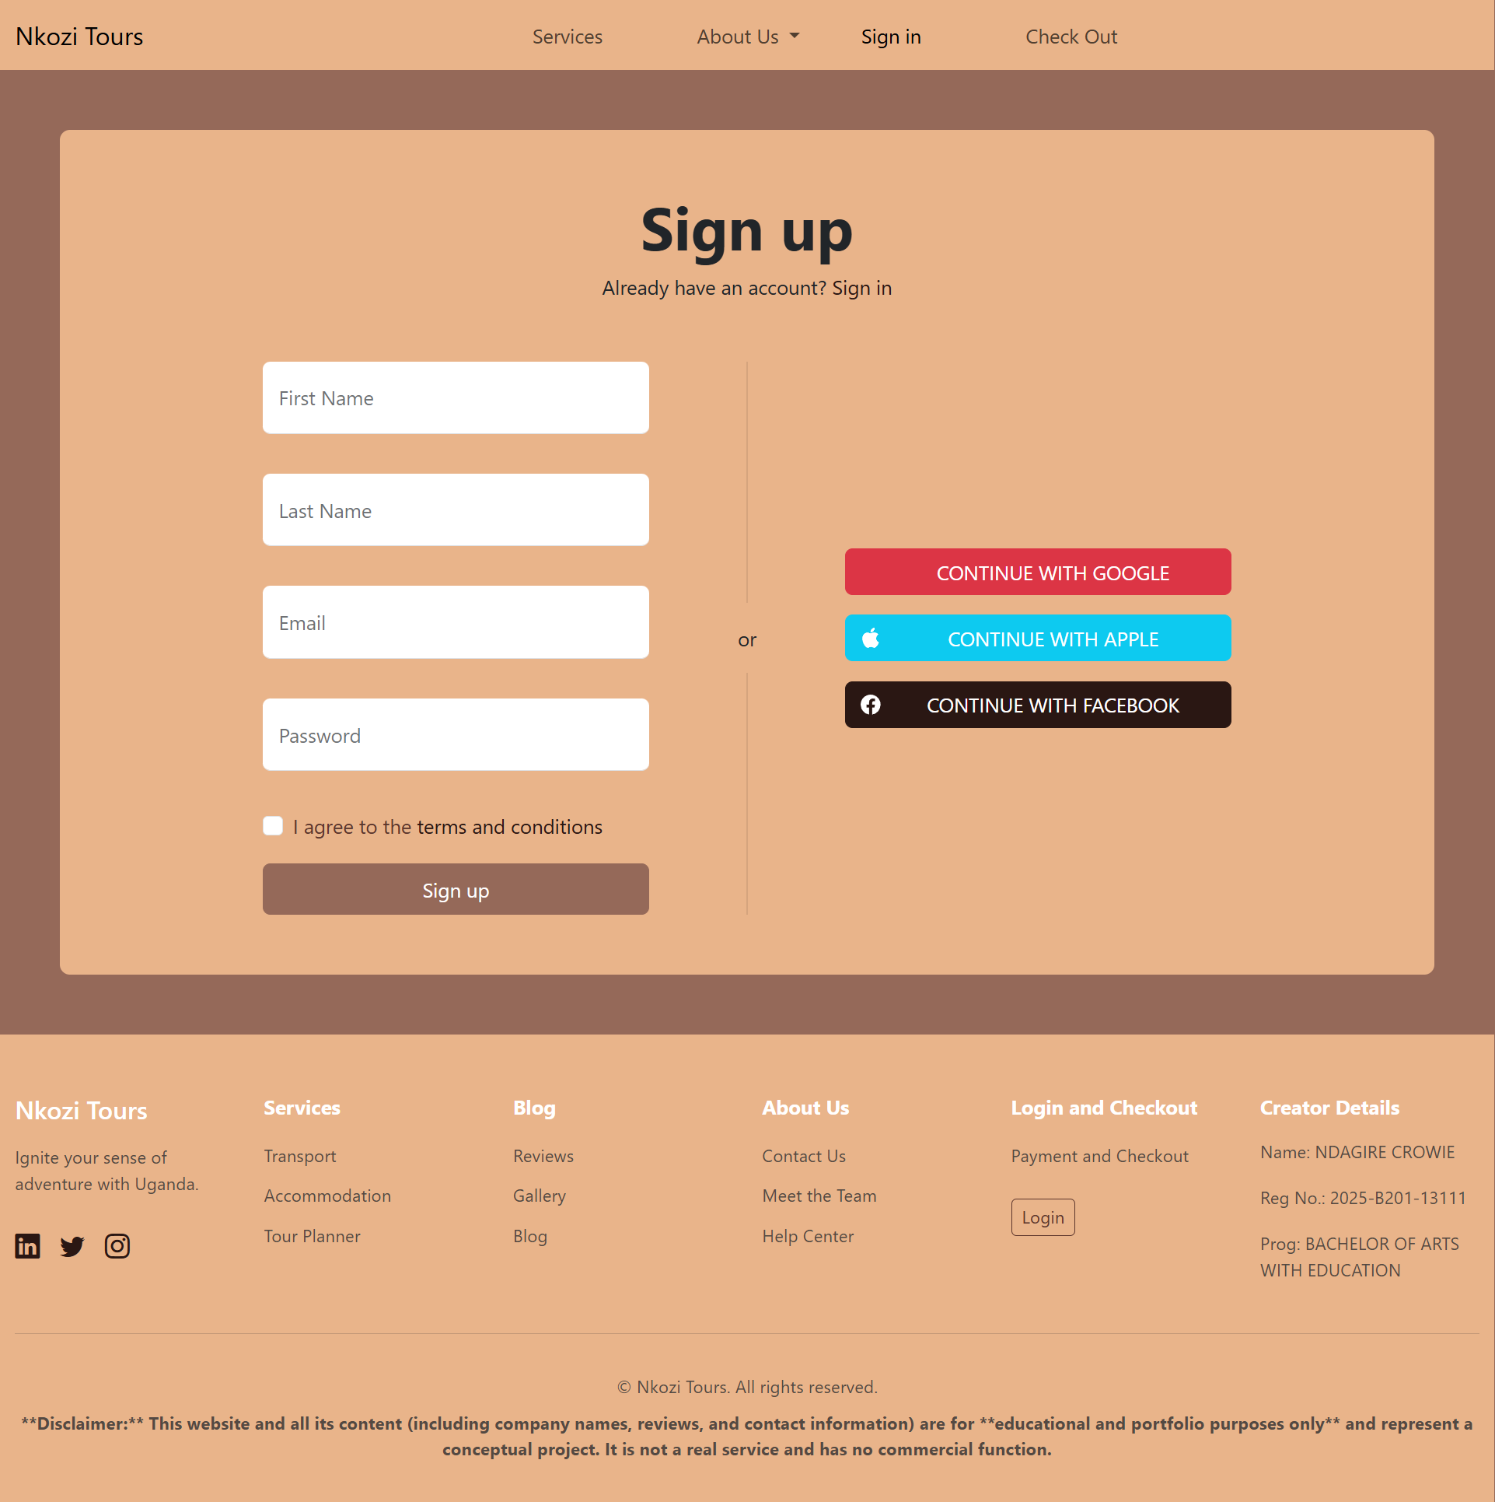

CHECK OUT

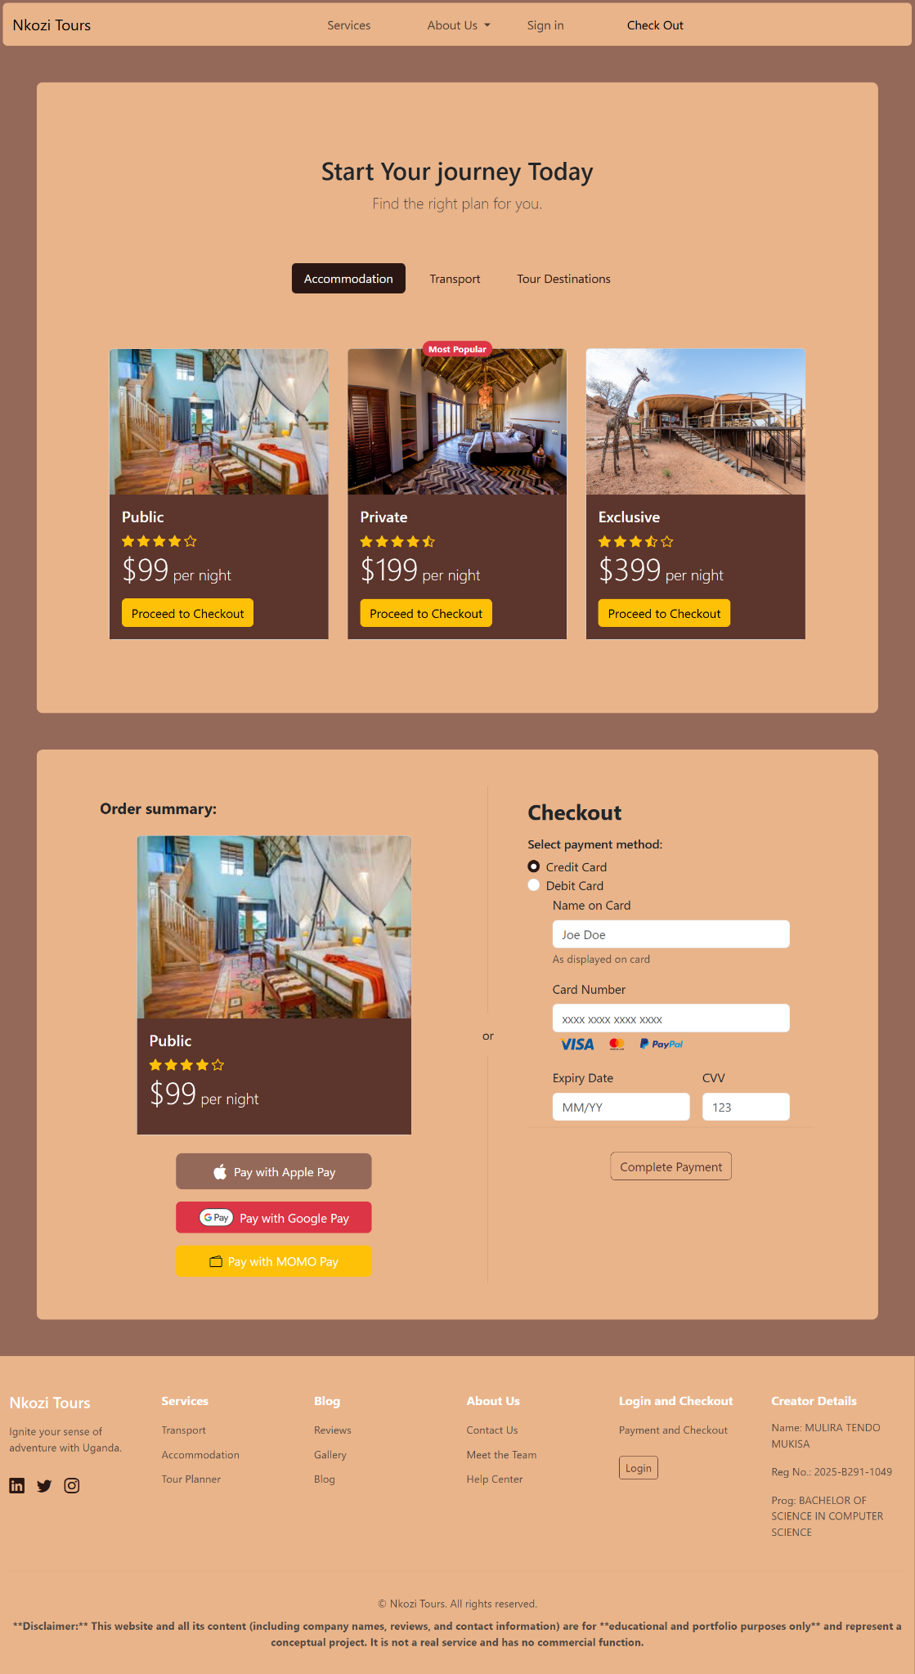

# Challenges faced and lessons learned

## Challenges faced

* Merging our branches into the main branch.
* Learning how to add APIs.
* Uploading work to GitHub.
* Using some bootstrap features.
* Learning how to use git bash when pushing the work.

## Lessons learned

* Collaborating on git hub.
* How to work with git branches
* How to upload work on git hub using git bash
* How to use some of the Bootstrap features

# Website Layout

## 

## Home

Carrousel

Links and page review

1. About Us - Vian

Dev info

About project

1. Services - Agaba

Tour Planner

Accomodation

Transport

1. Signup & Login - Crowie

Form

Help

Login

Username

Password

Sign up

First and Last name

Email

Password and confirm

1. Blog - Fredrick

Reviews

Image gallery

1. Checkout - Mulira

Pricing

Payment and Checkout

1. Contact & Help - Vincent

Contact Info

Contact form

FAQ